Day 24 - 104608492 - Shirisha Perapagu

Design Patterns

* Creational Design Patterns
  1. Singleton
  2. Factory Method
  3. Abstract Factory
  4. Builder
  5. Prototype

Task 1

Abstract Factory Design Pattern – Mobile Brand Selector

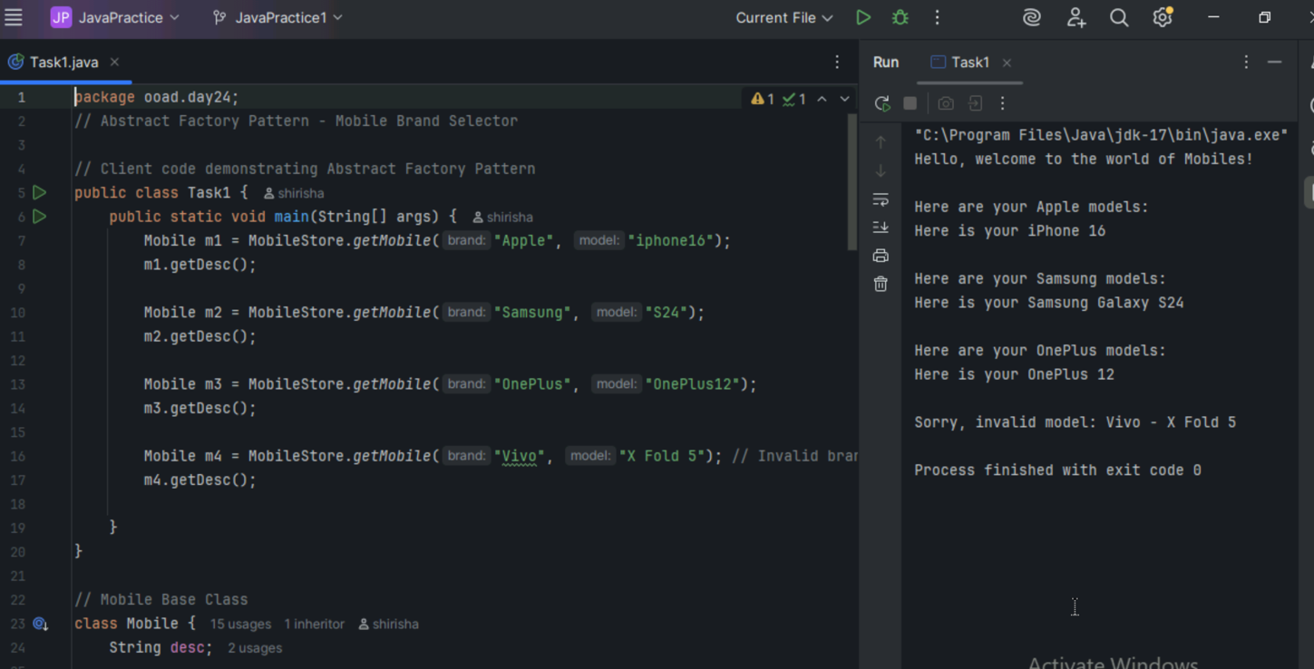

Task 2

Builder Design Pattern – Laptop Customization

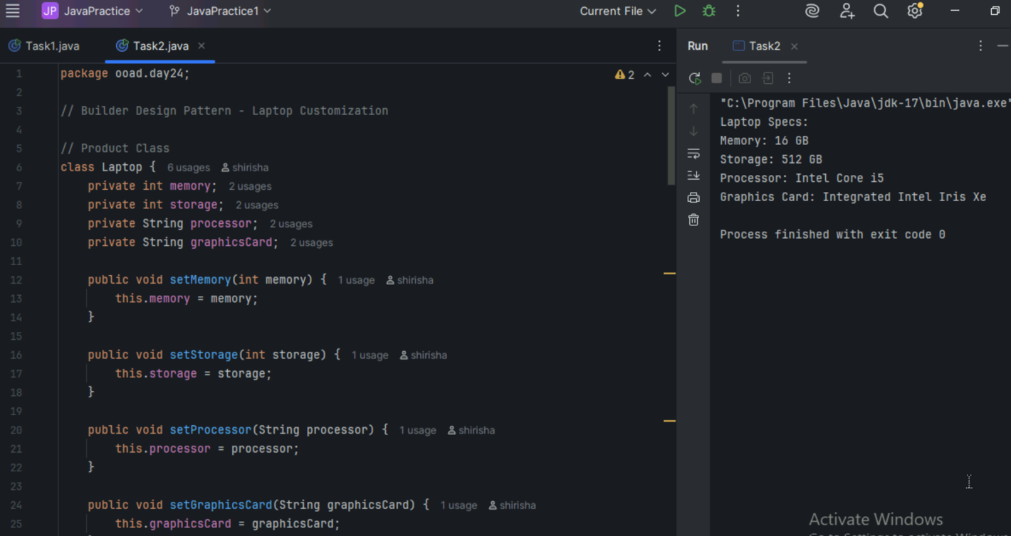

Task 3

Prototype Design Pattern – Color Cloning Example

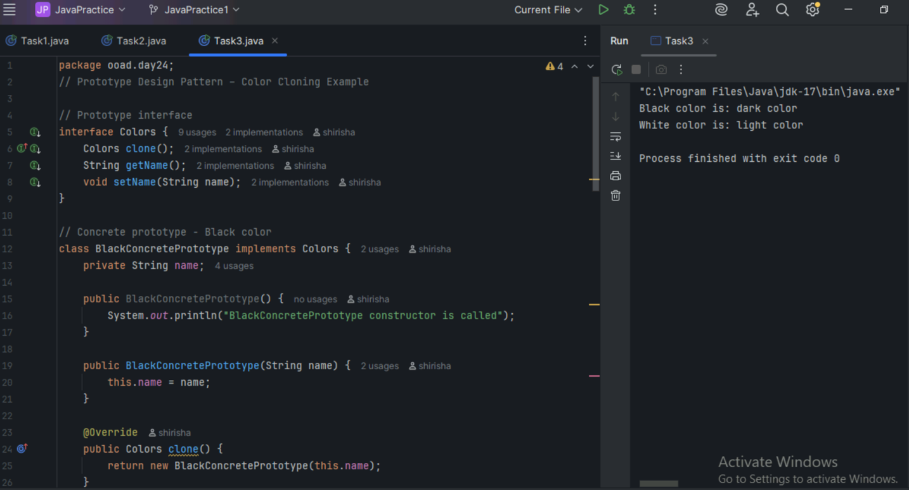

========================================================================

Home tasks

========================================================================

Task4:

Develop the below prototype method DP

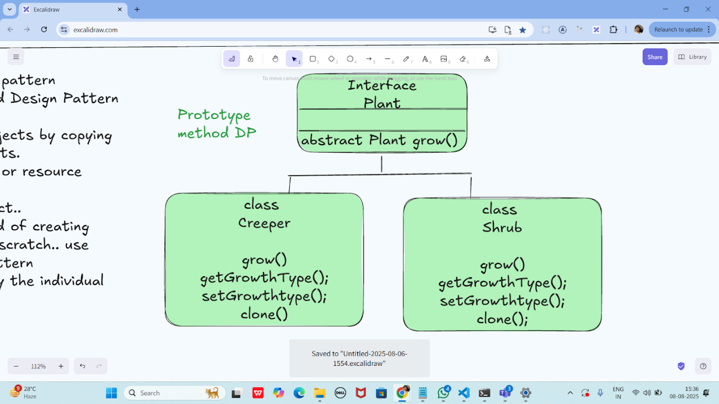

Solution:

